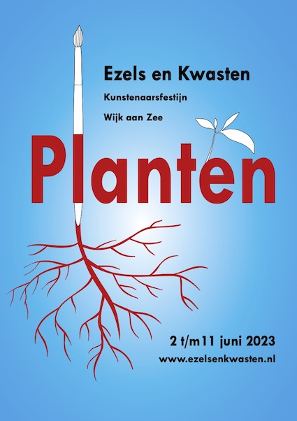
INVITATION Ezels en Kwasten

D
ear art friend,

W
e are delighted to invite you to participate in the 2023 edition of Ezels en Kwasten, the famous art festival of Wijk aan Zee. This year the event will take place on June 2 till June 11. We will start on June 2 at 11 AM with the opening speech, followed by a communal lunch to which you are heartily invited. Please indicate on the registration form whether you wish to accept this invitation.
After lunch we will find our way in Wijk aan Zee and start working.

T
his year’s theme is ‘PLANTS’ and as always it’s completely left to your own imagination how you wish to interpret this.
D
on’t hesitate to share this invitation with your art friends, invite them to join you in Wijk aan Zee in June.
O
f course there will be numerous workshops for you to join during Ezels and Kwasten. You’ll find all the relevant information once you are here.
T
he actual programme will be published on the Ezels en Kwasten website shortly. www.ezelsenkwasten.nl
L
ooking forward to welcoming you in Wijk aan Zee, see you in June.

CONDITIONS FOR PARTICIPATION
- The minimum amount of participants is 30, maximum 100
- By registering you agree with these conditions without reservations
- Every participant will at least provide one and maximum three pieces for the exhibition on June 10 and 11
- Every participant will provide one piece for sale during the auction on the 11th of June
- Provided work for the auction will not be sold to third parties for the duration it is in the care of Ezels en Kwasten
- Participating means you will spend at least 50% of your time working in one of the studios unless you will be working on one of the public locations spread across the village
- As a participant you will demonstrate an open attitude towards the visiting public
- Registering for a workshop contains the obligation to attend. If unable to comply you will notify the organisers
- Paid registration fees will not be refunded
- Failure to adhere to these conditions will lead to exclusion of further participation this year and in the future.

SEE REVERSE FOR THE REGISTRATION FORM

Registration Form Ezels en Kwasten 2023

Please return as soon as possible but definitely before May 1st 2023
Please read the conditions for participation carefully on the reverse side. Registering means you agree with these conditions without reservation.

Herewith I register for participation in Ezels en Kwasten 2023 from Friday June 2nd till Sunday June 11th.

Name: O male O female

Address:

Postal code/ Place:

Country:

Telephone number:

Email address:

I will / will not join the communal lunch on Friday June 2nd

Registration fee is €35 p.p. payable to IBAN NL54INGB0004854771 of Stichting KOP van WaZ. Please state: ‘Ezels en Kwasten 2023’ and your name.

Send this completed form as soon as possible to:
ezelsenkwasten@gmail.com

Your registration will only be completed after receipt of the registration fee before May 1st 2023

We are happy that you will join us. Feel very welcome in Wijk aan Zee in June 2023.

Be advised, Ezels en Kwasten will NOT mediate in finding accommodation in Wijk aan Zee during your stay.

